**Advanced Web Programming Project 2022**

**Topic: Grocery Management**

**Name: Prerna Vishnu Jadhav**

**Project Synopses:**

The following project of the grocery management system consists shopping of for fruits and vegetables in general. The mechanism of the project is like any other online shopping website. There is one master page. The master page includes the category of shopping i.e vegetables and fruits accordingly along with the cart, about us, and payment option thereafter. A user has to first register and then log in. The user will be accessible to the content pages(which are not part of master page) only after logging in successfully. Once the user logged in, it is now feasible to select from multiple options of fruits and veggies. On selection of fruit and quantity of fruits and vegetables, he will be specified the bill on each new item added. Once the user selected items and is ready to proceed he will be directed to the ‘cart’ page to confirm his orders and accordingly the bill. Lastly to pay the bill the user will be directed to the ‘Payment’ page where his card details and address will be stored in the database. While building the project, all the requirements like master page, content page, skin files, state management techniques, database, calendar controls and validators are included.

**Site1.Master**

**Output/Design:**

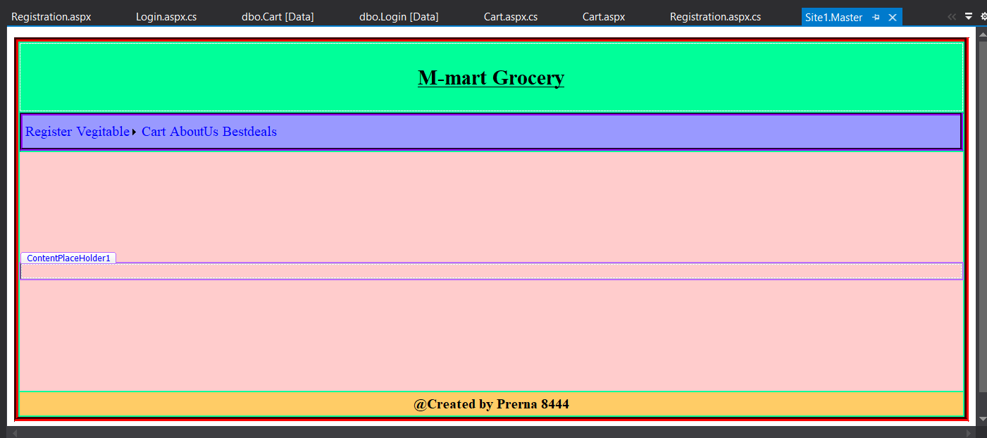

**Content-Pages:**

**1.Registration**

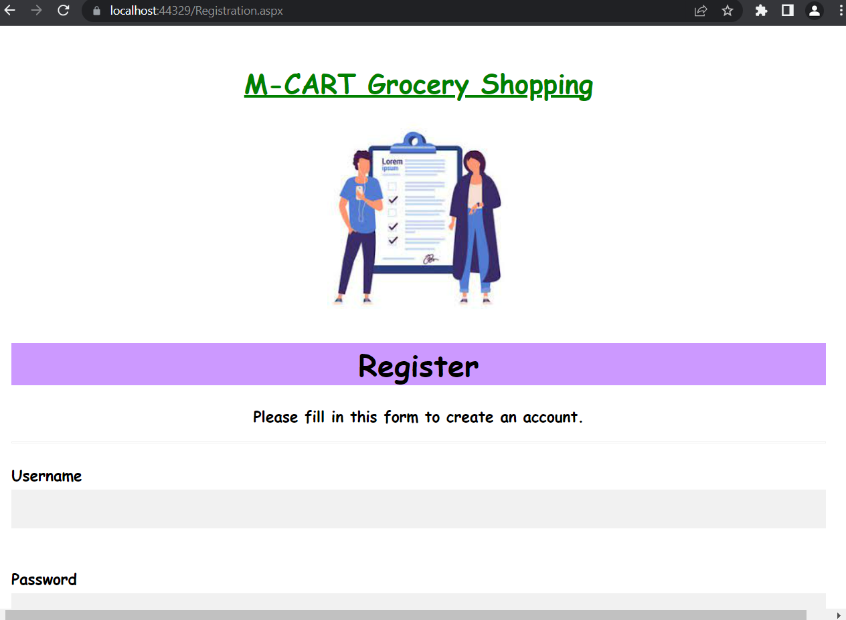

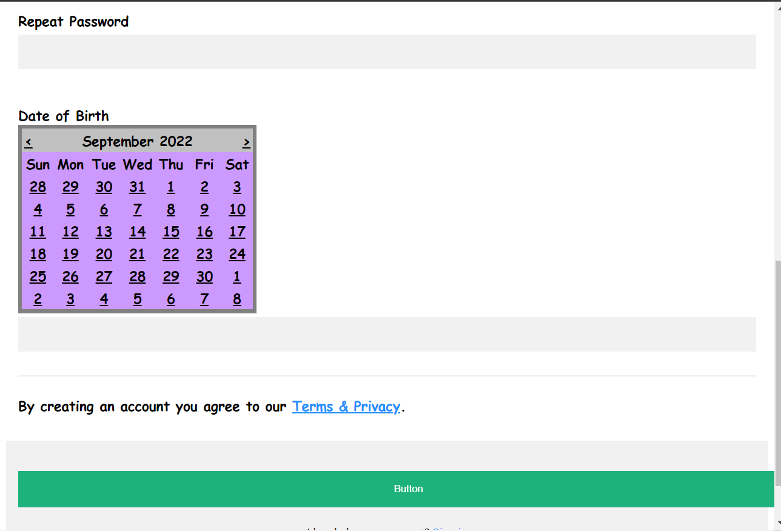



**Login**

**Code:**

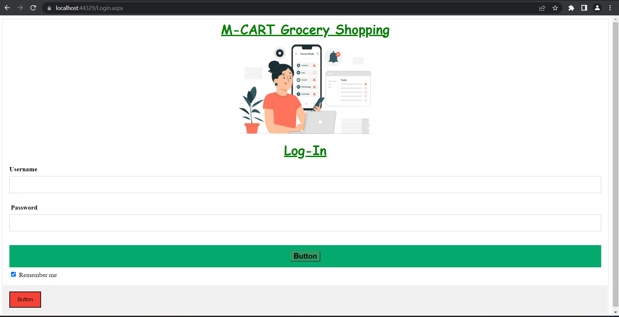

**3.Fruits**

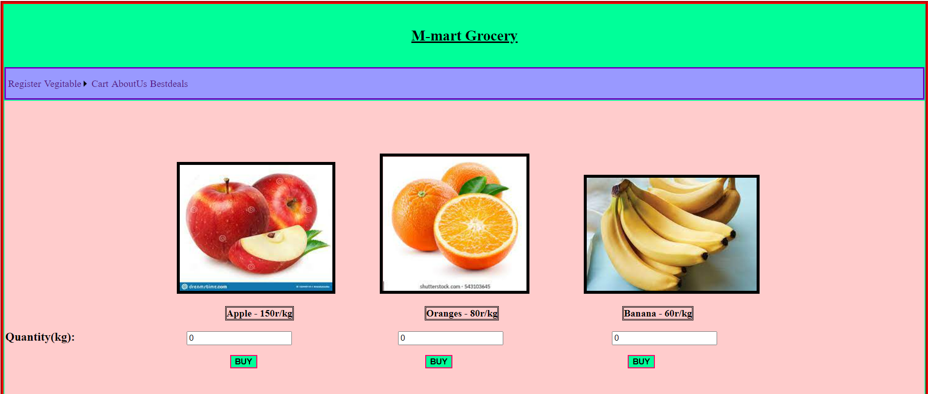

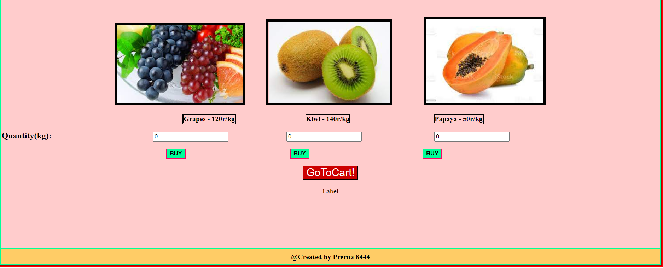

**4.Vegitable**

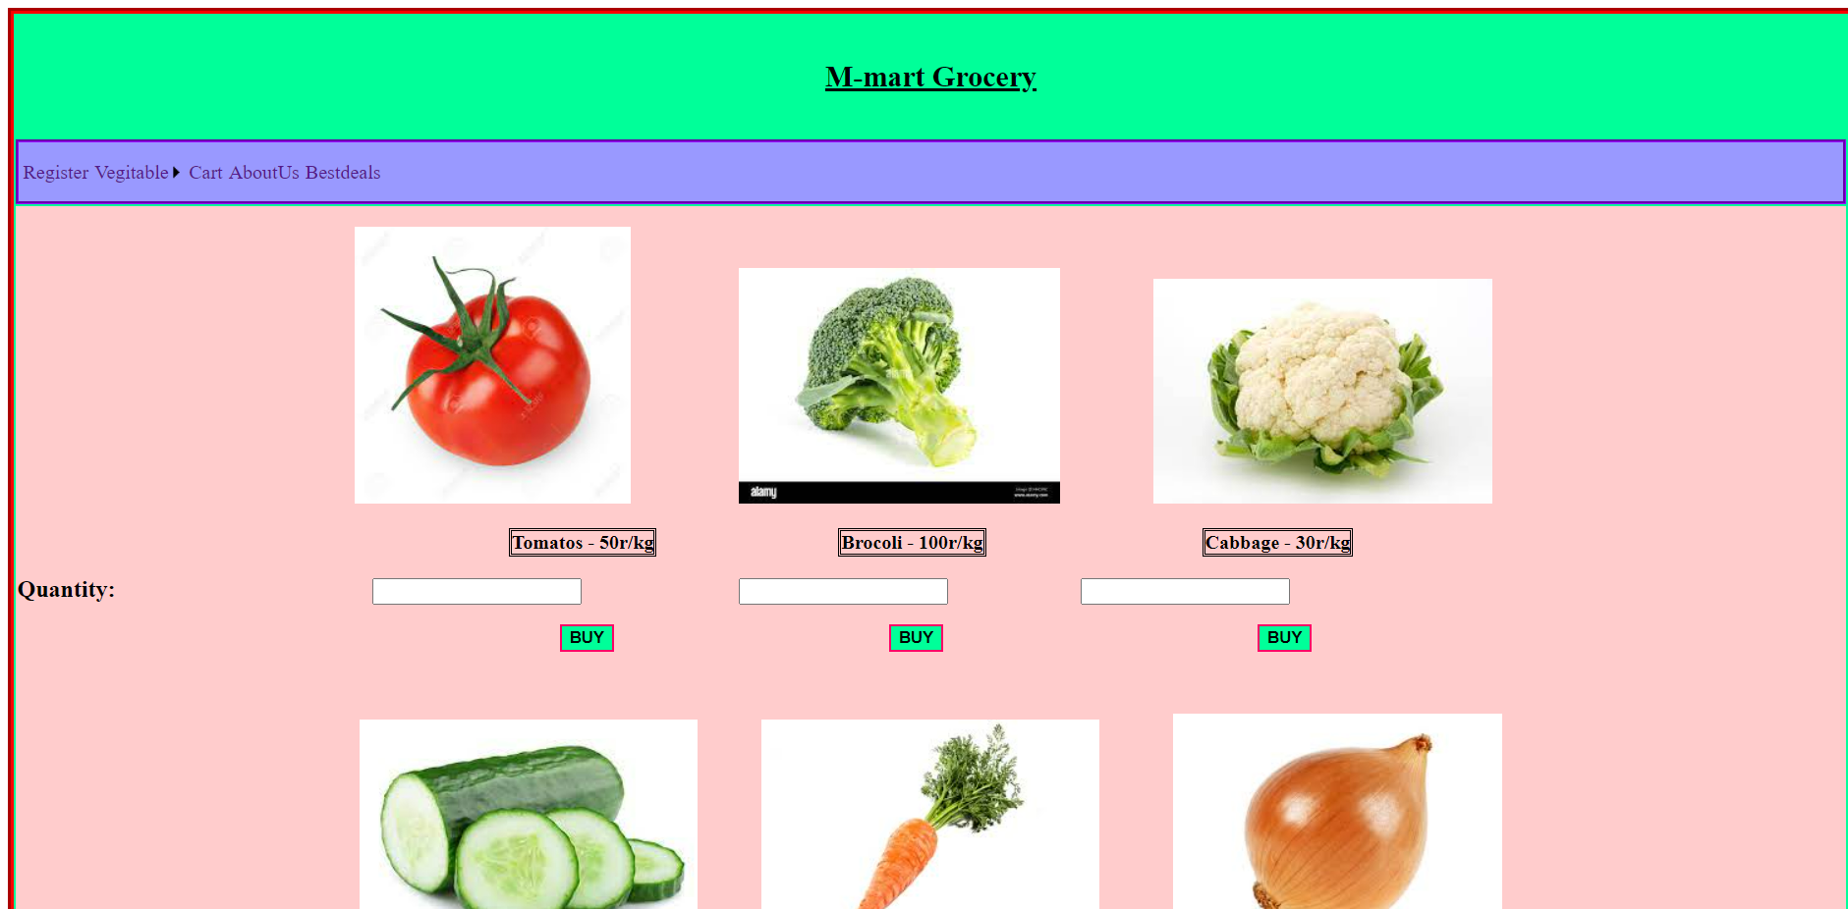 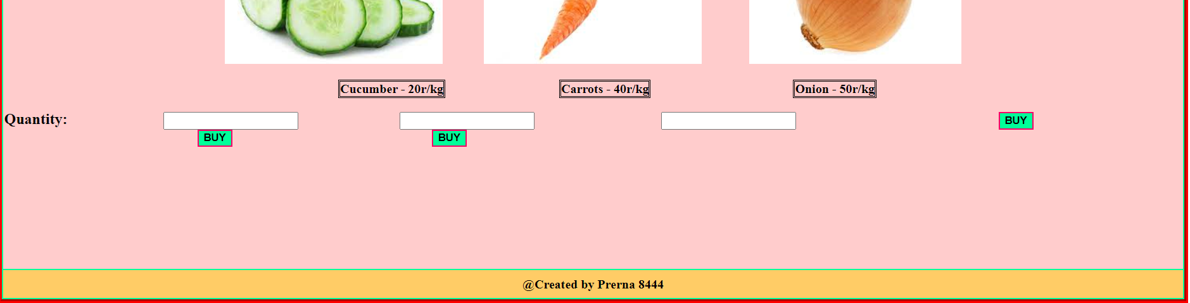

**5.Cart**

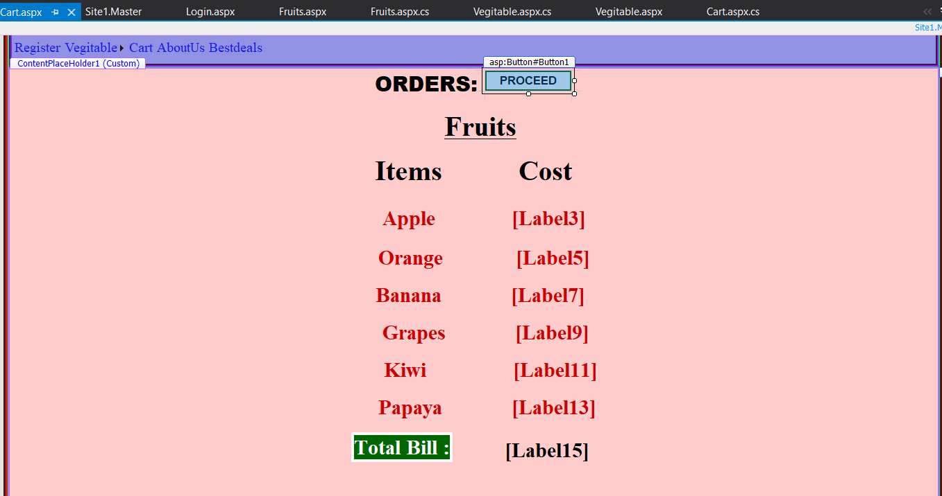

**6.Payement**

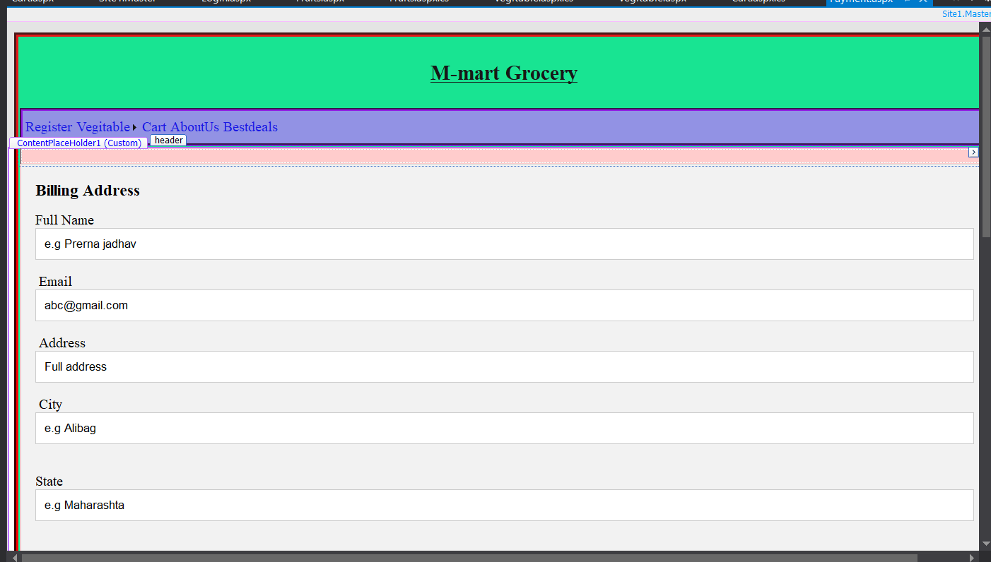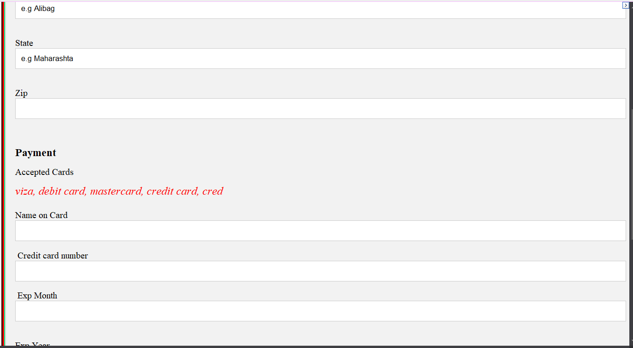

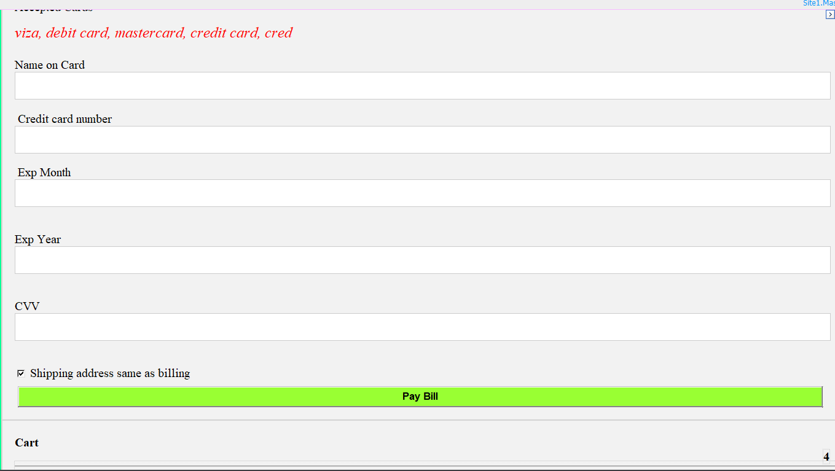

**7.Done**

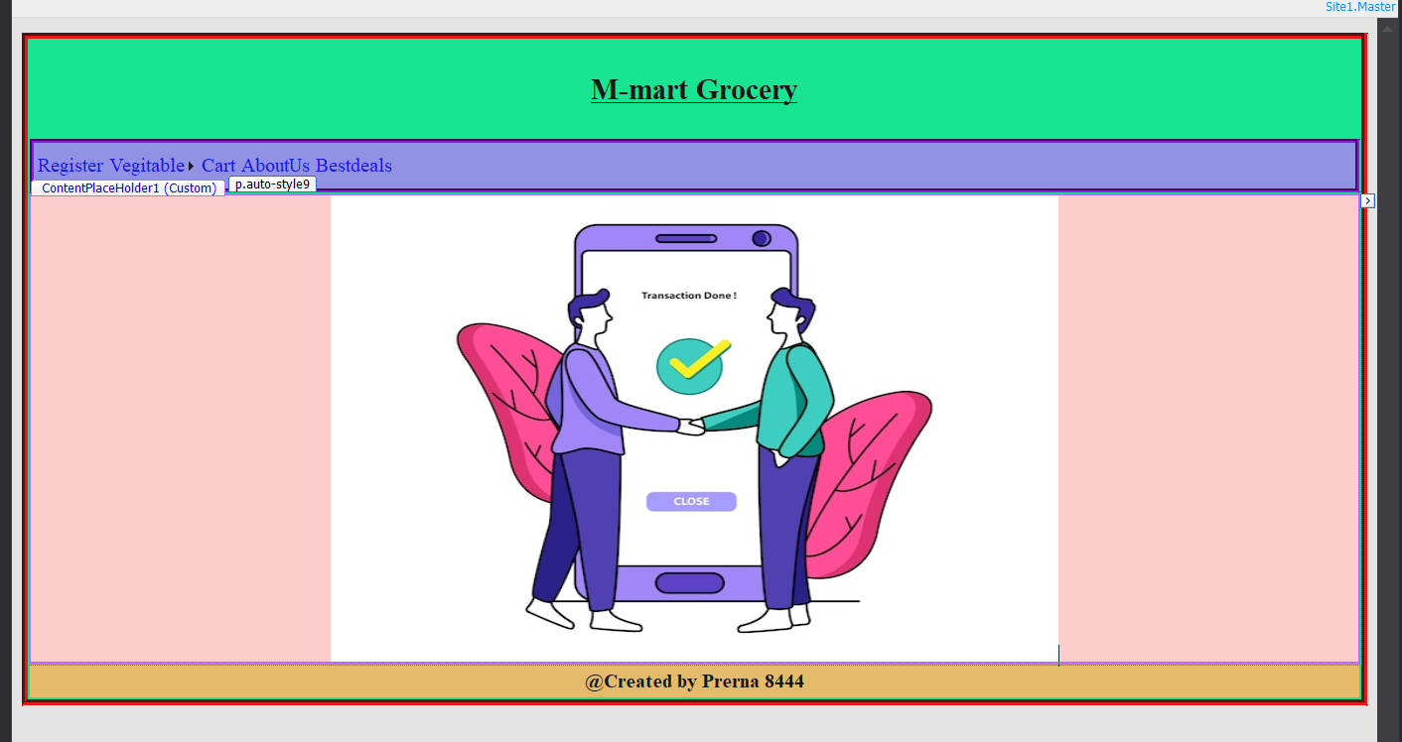

**Mechanism**

**Step1: Registration**

**1.Use of validators**

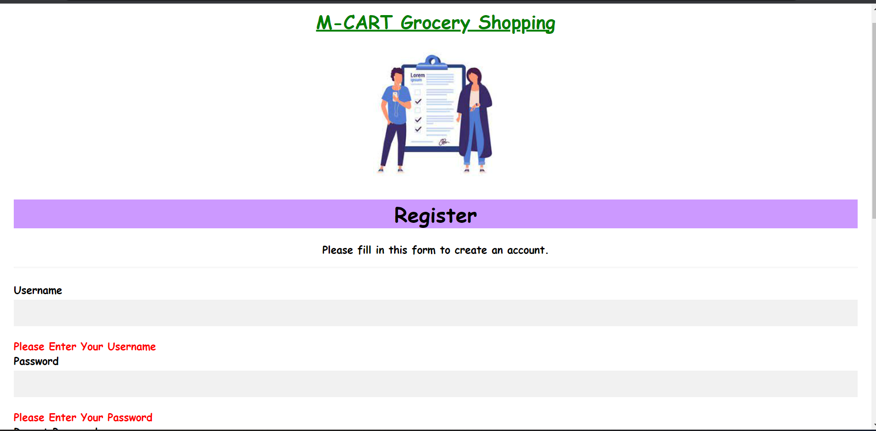 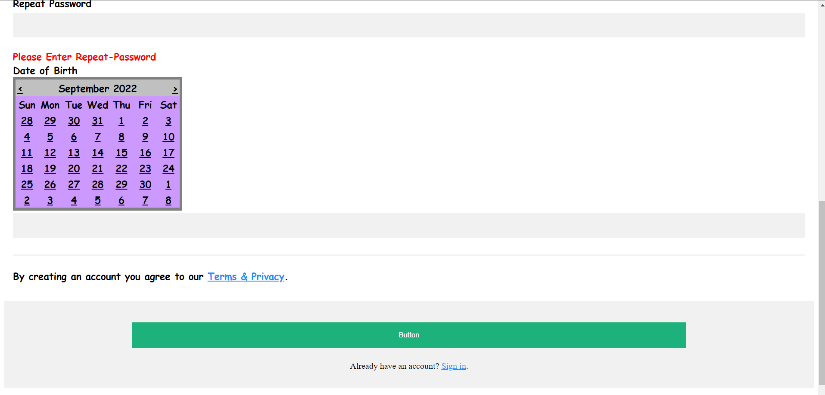

**Registration**

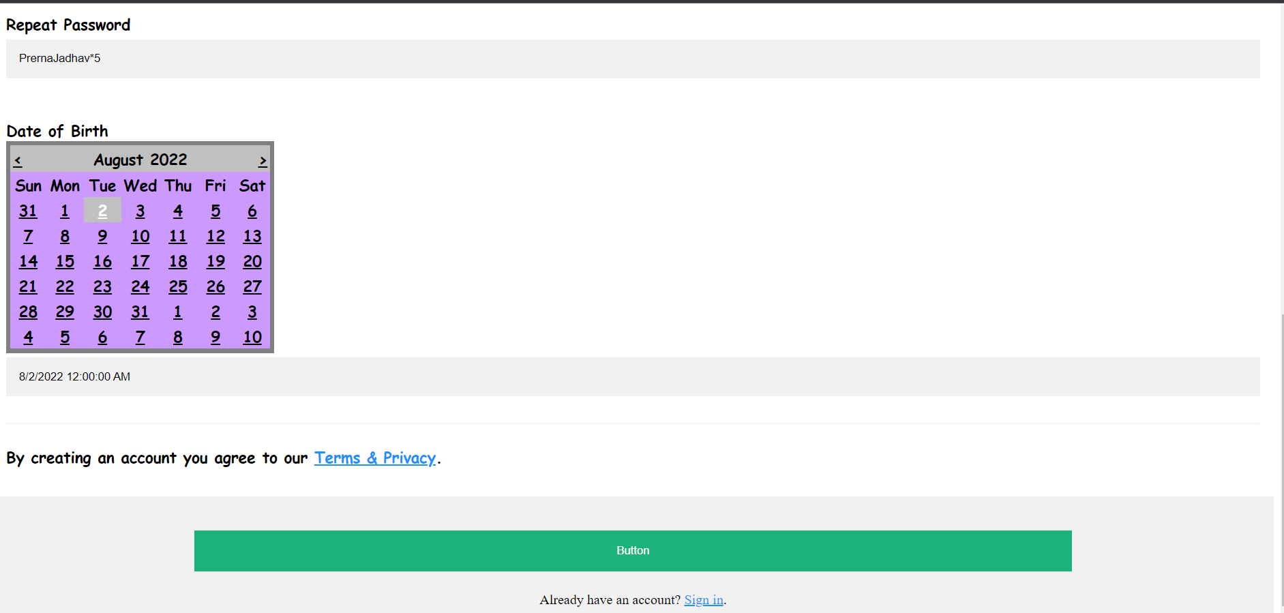

**2.Login**

**Invalid Login**

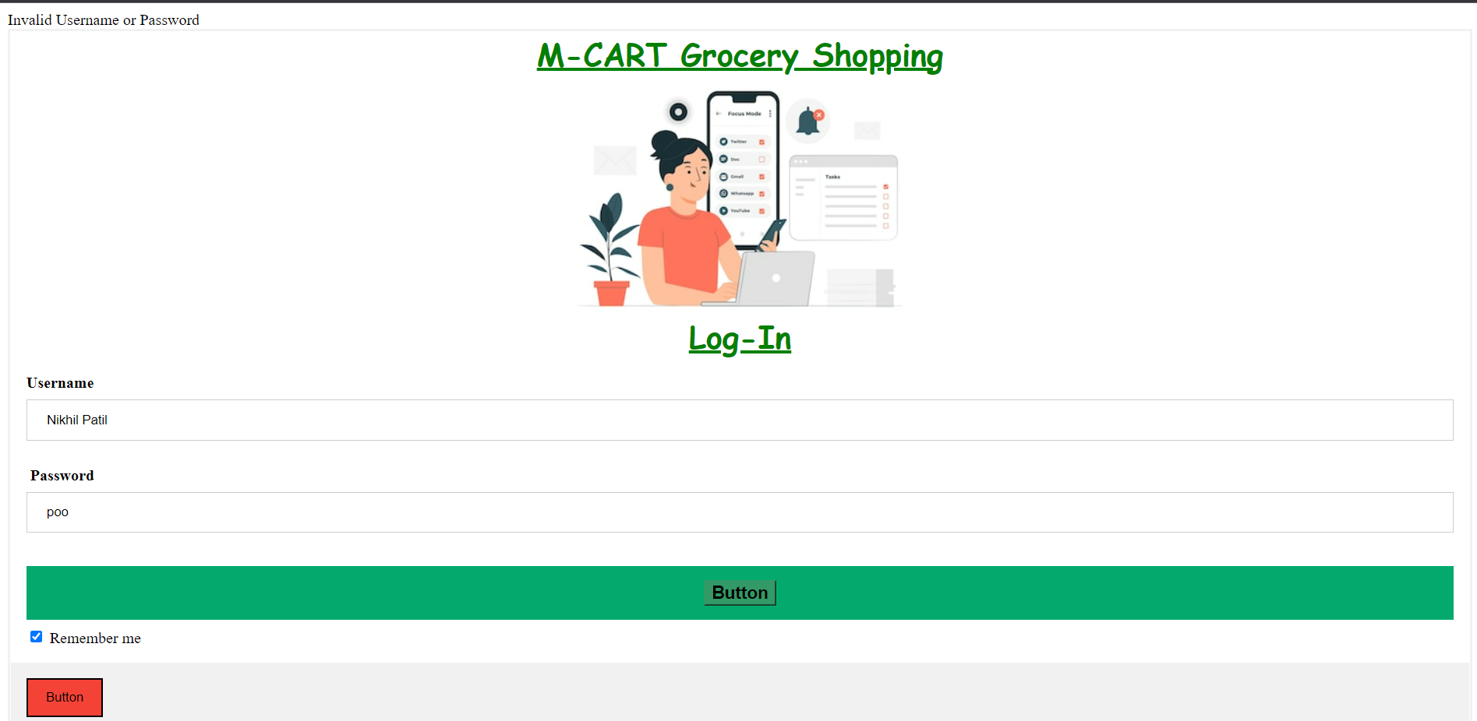

**Valid Login**

**After Valid login user will be directed to fruits.aspx page**

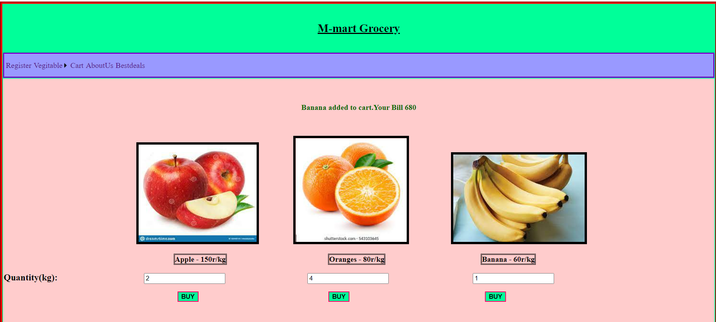 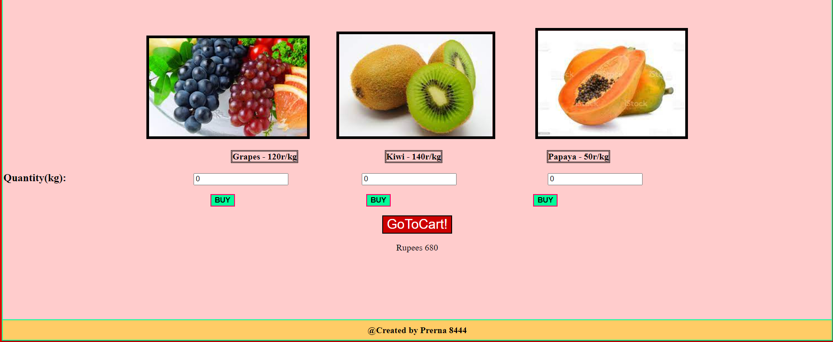

**On Clicking on Co to cart**

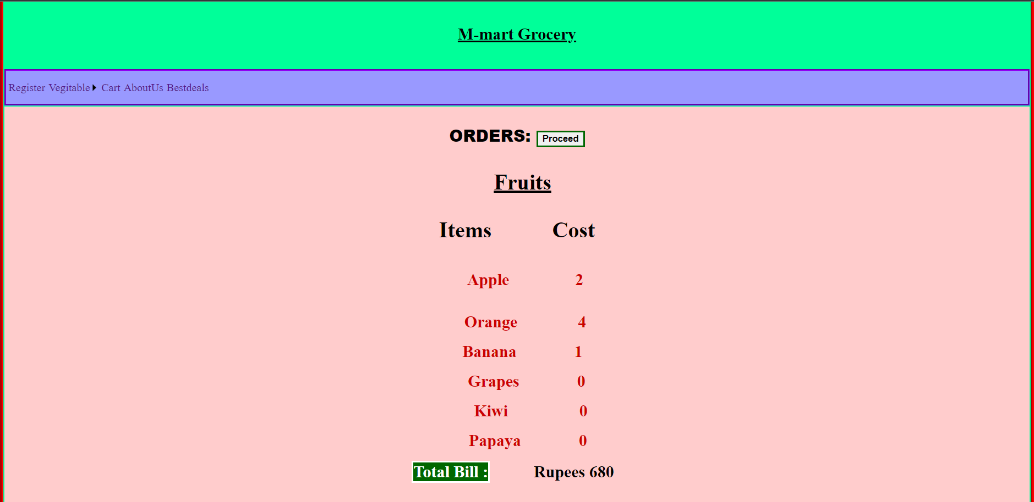

**Lastly On Clicking Pay bill the program will end with done.aspx**

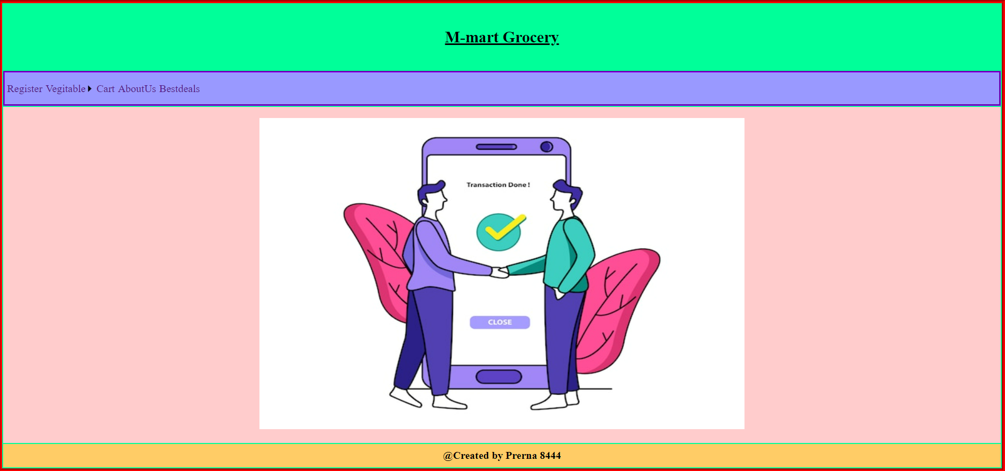

**Skin File**

